DETECTING COVID-19 with CHEST X-RAY
This project report is submitted to
Rashtrasant Tukadoji Maharaj Nagpur University

In partial fulfillment of the requirement
For the award of the degree (Mini-Project)

Of

Bachelor of Engineering in
Computer Science & Engineering

By

Achal Madewar
Niharika Mahajan
Rupal Manwatkar
Ameya Jajulwar
Sanket Gharge

Under the guidance of
Prof. Kalyani Pendke


DEPARTMENT OF COMPUTER SCIENCE & ENGINEERING
Nagar Yuwak Shikshan Sanstha’s
RAJIV GANDHI COLLEGE OF ENGINEERING & RESEARCH, NAGPUR-441110
(An institution affiliated to Rashtrasant Tukadoji Maharaj Nagpur University, Nagpur)
Session
2020-2021

CERTIFICATE OF APPROVAL

Certified that the project report entitled “DETECTION OF COVID-19 WITH CHEST X-RAY” has been successfully completed by Achal Madewar, Niharika Mahajan, Rupal Manwatkar, Ameya Jajulwar, Sanket Gharge under the guidance of Prof. Kalyani Pendke in recognition to the partial fulfillment for the award of the degree of Bachelor of Engineering in Computer Science & Engineering , Session 2020-2021, Rajiv Gandhi College of Engineering & Research, Nagpur (An Institution Affiliated to Rashtrasant Tukdoji Maharaj Nagpur University)

(Signature)
(Prof. Kalyani Pendke)
CSE Dept.

(Signature) (Signature)
Dr.H.R.Turkar Dr. Manali M. Kshirsagar

HOD, CSE Dept. Principal, RGCER

DECLARATION

I certify that

- The work contained in this project has been done by me under the guidance of my supervisor(s).
- The work has not been submitted to any other Institute for any degree or diploma.
- I have followed the guidelines provided by the Institute in preparing the project report.
- I have conformed to the norms and guidelines given in the Ethical Code of Conduct of the Institute.
- Whenever I have used materials (data, theoretical analysis, figures, and text) from other sources, I have given due credit to them by citing them in the text of the report and giving their details in the references. Further, I have taken permission from the copyright owners of the sources, whenever necessary.

Signature of the Students

(Name of the students)

Achal Madewar
Niharika Mahajan
Rupal Manwatkar
Ameya Jajulwar
Sanket Gharge

ACKNOWLEDGEMENT

We are extremely thankful to our guide Prof. Kalyani Pendke under whom our project took the shape of reality from mere idea. We are thankful to our guide for enlightening us with his/her precious guidance and constant encouragement. We thank our guide for providing us with ample support and valuable time. We are indebted to our guide who constantly provided a stimulus to reach our goals.
We are grateful to Dr. Hemant Turkar, HOD Name of department, RGCER, for his/her kind co-operation and timely help.
We express our gratitude towards Dr. S.Mahakalkar, Dean Academics, RGCER, for his never ending support, planning and motivation.
We express our gratitude towards Dr. Manali M. Kshirsagar, Principal RGCER, for her never ending support and motivation.
Lastly, we would like to thank all those who were directly or indirectly related to our project and extended their support to make the project successful.

Name of Projectees
- Achal Madewar
- Niharika Mahajan
- Rupal Manwatkar
- Ameya Jajulwar
- Sanket Gharge

CONTENTS Page No.

Title Page i
Certificate of Approval ii
Declaration iii
Acknowledgement iv
Table of Contents v
List of Tables vii
List of Figures viii
Abstract ix
CHAPTER 1 INTRODUCTION 1
  - Overview
1.2 Problem Statement
1.3 Thesis Objectives
1.4 Thesis Contributions …
CHAPTER 2 REVIEW OF LITERATURE
2.1 Overview

CHAPTER 3 WORK DONE :( Report on the present investigation)
3.1 System Diagram
3.2 Modules

CHAPTER 4 RESULTS AND DISCUSSIONS
4.1 Screen shots of Results (Along with detailed description of Result)

CHAPTER 5 CONCLUSIONS AND FUTURE SCOPE
5.1 Conclusions
5.2 Future Scope

CHAPTER 6 – REFERENCES

ABSTRCT
The exponential increase in COVID-19 patients is overwhelming healthcare systems across the world. With limited testing kits, it is impossible for every patient with respiratory illness to be tested using conventional techniques (RT-PCR). The tests also have long turn-around time, and limited sensitivity. Detecting possible COVID-19 infections on Chest X-Ray may help quarantine high risk patients while test results are awaited. X-Ray machines are already available in most healthcare systems, and with most modern X-Ray systems already digitized, there is no transportation time involved for the samples either. In this work we propose the use of chest X-Ray to prioritize the selection of patients for further RT-PCR testing. This may be useful in an inpatient setting where the present systems are struggling to decide whether to keep the patient in the ward along with other patients or isolate them in COVID-19 areas. It would also help in identifying patients with high likelihood of COVID with a false negative RT-PCR who would need repeat testing. COVID-19 pandemic is causing a major outbreak in more than 150 countries around the world, having a severe impact on the health and life of many people globally. One of the crucial step in fighting COVID-19 is the ability to detect the infected patients early enough, and put them under special care. Detecting this disease from radiography and radiology images is perhaps one of the fastest ways to diagnose the patients. Some of the early studies showed specific abnormalities in the chest radiograms of patients infected with COVID-19. Inspired by earlier works, we study the application of deep learning models to detect COVID-19 patients from their chest radiography images. We first prepare a dataset of 5,000 Chest X-rays from the publicly available datasets. Images exhibiting COVID-19 disease presence were identified by board-certified radiologist. Transfer learning on a subset of 2,000 radiograms was used to train four popular convolutional neural networks, including ResNet18, ResNet50, SqueezeNet, and DenseNet-121, to identify COVID-19 disease in the analyzed chest X-ray images. We evaluated these models on the remaining 3,000 images, and most of these networks achieved a sensitivity rate of 98% (± 3%), while having a specificity rate of around 90%. Besides sensitivity and specificity rates, we also present the receiver operating characteristic (ROC) curve, precision-recall curve, average prediction, and confusion matrix of each model. We also used a technique to generate heatmaps of lung regions potentially infected by COVID-19 and show that the generated heatmaps contain most of the infected areas annotated by our board certified radiologist. While the achieved performance is very encouraging, further analysis is required on a larger set of COVID-19 images, to have a more reliable estimation of accuracy rates. The dataset, model implementations (in PyTorch), and evaluations, are all made publicly available for research community at https://g.git ithub.com /shervinmin/DeepCovid.

CHAPTER 1: INTRODUCTION

  - Background
Since December 2019, a novel corona-virus (SARS-CoV-2) has spread from Wuhan to the whole China, and many other countries. By April 18, more than 2 million confirmed cases, and more than 150,000 deaths were reported in the world [1]. Since December 2019, a novel corona-virus (SARS-CoV-2) has spread from Wuhan to the whole China, and many other countries. By April 18, more than 2 million confirmed cases, and more than 150,000 deaths were reported in the world [1]. Covid-19 is a rapidly spreading viral disease that infects not only humans, but animals are also infected because of this disease. The daily life of human beings, their health, and the economy of a country are affected due to this deadly viral disease. Covid-19 is a common spreading disease. A clinical study of COVID-19 infected patients has shown that these types of patients are mostly infected from a lung infection after coming in contact with this disease. Chest x-ray (i.e., radiography) and chest CT are a more effective imaging technique for diagnosing lunge related problems. Still, a substantial chest x-ray is a lower cost process in comparison to chest CT. Deep learning is the most successful technique of machine learning, which provides useful analysis to study a large amount of chest x-ray images that can critically impact on screening of Covid-19. In this work, we have taken the PA view of chest x-ray scans for covid-19 affected patients as well as healthy patients. After cleaning up the images and applying data augmentation, we have used deep learning-based CNN models and compared their performance. We have compared Inception V3, Xception, and ResNeXt models and examined their accuracy. To analyze the model performance, 6432 chest x-ray scans samples have been collected from the Kaggle repository, out of which 5467 were used for training and 965 for validation. In result analysis, the Xception model gives the highest accuracy (i.e., 97.97%) for detecting Chest X-rays images as compared to other models. This work only focuses on possible methods of classifying covid-19 infected patients and does not claim any medical accuracy.

  - Problem Statement
The sudden spike in the number of patients with COVID-19, a new respiratory virus, has put unprecedented load over healthcare systems across the world. In many countries, the healthcare systems have already been overwhelmed. There are limited kits for diagnosis, limited hospital beds for admission of such patients, limited personal protective equipment (PPE) for healthcare personnel and limited ventilators. It is thus important to differentiate which patients with severe acute respiratory illness (SARI) could have COVID-19 infection in order to efficiently utilize the limited resources.

  - Thesis Objective
In this work we propose the use of chest X-Ray to detect COVID-19 infection in the patients exhibiting symptoms of SARI. Using our tool COVID x-19 NET, Deep Convolution Neural Network model one can classify a given X-Ray in one of the four classes: normal, bacterial pneumonia, viral pneumonia, and covid pneumonia. We used the chest x-ray images that are available for the open source from covid-chest-x ray-dataset and combined them with the publicly available chest x-ray images from National Institutes of Health Clinical centre (NIH).
The use of X-Ray has several advantages over conventional diagnostic tests:
1. X-Ray imaging is much more widespread and cost effective than the conventional diagnostic tests.
2. Transfer of digital X-Ray images does not require any transportation from point of acquisition to the point of analysis, thus making the diagnostic process extremely quick.
3. Unlike CT Scans, portable X-Ray machines also enable testing within an isolation ward itself, hence reducing the requirement of additional Personal Protective Equipment (PPE), an extremely scarce and valuable resource in this scenario.
The main contribution of this work is in proposing a novel deep neural network based model for highly accurate detection of COVID-19 infection from the chest X-Ray images of the patients.

1.4 Thesis Contribution
Therefore this automated tool can serve as a guide for those in the forefront of this analysis. We would like to re-emphasize that we are not proposing the use of the proposed model as alternative to the conventional diagnostic tests for COVID-19 infection, but as a triage tool to determine the suitability of a patient with SARI to undergo the test for COVID-19 infection.

COVID-Xray-5k Dataset:

Chest X-ray images from two datasets formed the COVIDXray-5k dataset that contains 2,084 training and 3,100 test images. One of the used datasets is the recently published CovidChestxray-Dataset, which contains a set of images from publications on COVID-19 topics, collected by Joseph Paul Cohen [9, 10]. This dataset contains a mix of chest X-ray and CT images. As of May 3, 2020, it contained 250 X-ray images of COVID-19 patients, from which 203 images are anterior posterior view. It is mentioned that this dataset is continuously updated. It also contains some meta-data about each patients, such as sex and age. Our COVID-19 images are all coming from this dataset. Based on our board-certified radiologist advice, only anterior-posterior images are kept for Covid-19 prediction, as the lateral images are not suitable for this purpose. The anterior-posterior images were examined by our boardcertified radiologist, and the ones without even the slightest radiographic signs of Covid-19 were removed from dataset. Out of 203 interior-exterior X-ray images of COVID-19, 19 of them were excluded, and 184 images (which showed clear signs of COVID-19) were kept by our radiologist. This way, we can provide the community a more cleanly labeled dataset. Out of these images, we chose 100 COVID-19 images to include in the test set (to meet some maximum confidence interval value), and 84 COVID-19 images for the training set. Data augmentation is applied to the training set to increase the number of COVID-19 samples to 420 as described above. We made sure all images for each patient go only to one of the training or test sets. It is worth mentioning that our radiologist marked the regions with specific signs of Covid-19. Since the number of Non-Covid images was very small in the [9] dataset, additional images were employed from the ChexPert dataset [11], a large public dataset for chest radiograph interpretation consisting of 224,316 chest radiographs of 65,240 patients, labeled for the presence of 14 sub-categories (nofinding, Edema, Pneumonia, etc.). For the non-COVID samples in the training set, we only used images belonging to a single sub-category, composed of 700 images from the no-finding class and 100 images from each remaining 13 sub-classes, resulting in 2,000 non-COVID images. As for the Non-COVID samples in the test dataset, we selected 1,700 images from the no-finding category and around 100 images from each remaining 13 sub-classes in distinct subfolders, resulting in 3000 images in total. The exact number of images of each class for both training and testing is given in Table 1. Table 1. Number of images per category in COVID-Xray-5k dataset. Split COVID-19 Non-COVID Training Set 84 (420 after augmentation) 2000 Test Set 100 3000 Figure 2 shows 16 sample images from COVID-Xray-5k dataset, including 4 COVID-19 images (the first row), 4 normal images from ChexPert (the second row), and 8 images with one of the 13 diseases in ChexPert (third and fourth rows). The images in the third and fourth rows give 8 sample images from other sub-categotries in ChexPert. It is worth mentioning that, there is wide variation in the resolution of images in this dataset. There are some low-resolution images in Covid-19 class (below 400x400), and some high resolutions ones (more than 1900x1400). This is a positive point for the models that can achieve a reasonable high accuracy on this dataset, despite this variable image resolution and imagery methodology. Collecting all images in a super-controlled environment that results in high-resolution and super-clean images, although desired, is not always doable, and as machine learning field progresses, more and more focus is directed toward models and frameworks that can work reasonably well on variable resolution, quality, and small-scale labeled datasets. Also the images of Covid-19 class are collected from multiple sources by the original provider, and some of them may show a different dynamic range from other ones (and also from ChexPert), but during the training all images are normalized to the same distribution to make model less sensitive to that.

CHAPTER 2: REVIEW OF LITERATURE

2.1 Background

Deep neural networks are useful for dealing with complex tasks. However, adding too many layers generally causes vanishing gradient problems, and the weights of the early layers cannot be updated by backpropagation. This can be solved by adding an identity connection. The structure of Resnet allows the gradients to flow backward directly through an identity connection from the later layers to the initial filters. ResNet is a continuation of deep networks. It improves CNN architecture with residual learning and offers an effective methodology for the training of deep networks.
Our dataset consisted of 1000 CXR images. We organized the dataset into three folders (60% training, 20% test, 20% validation) containing subfolders for each image category (300 COVID-19, 350 normal, and 350 viral pneumonia images). The confusion matrices of COV19-CNNet and COV19-ResNet were calculated to investigate their performances. As shown in Fig. 4a, the COVID-19 and normal classes achieved perfect classification with the use of COV19-CNNet, whereas the viral pneumonia class had 12 misclassified samples within the 70 test samples. On the other hand, as seen in Fig. 4b, COVID-19 achieved the perfect classification with the use of COV19-ResNet; the normal class had three misclassified samples and the viral pneumonia class had two misclassified samples within the 30 test samples. According to these confusion matrixes, the accuracy performances for COV19-ResNet and COV19-CNNet are 97.61% and 94.28%, respectively.
The Proposed Framework

To overcome the limited data sizes, transfer learning was used to fine-tune four popular pre-trained deep neural networks on the training images of COVID-Xray-5k dataset. 3.1. Transfer Learning Approach In transfer learning, a model trained on one task is repurposed to another related task, usually by some adaptation toward the new task. For example, one can imagine using an image classification model trained on ImageNet (which contains millions of labeled images) to initiate task-specific learning for COVID-19 detection on a smaller dataset. Transfer learning is mainly useful for tasks where enough training samples are not available to train a model from scratch, such as medical image classification for rare or emerging diseases. This is especially the case for models based on deep neural networks, which have a large number of parameters to train. By using transfer learning, the model parameters start with already-good initial values that only need some small modifications to be better curated toward the new task. There are two main ways in which the pre-trained model is used for a different task. In one approach, the pre-trained model is treated as a feature extractor (i.e., the internal weights of the pre-trained model are not adapted to the new task), and a classifier is trained on top of it to perform classification. In another approach, the whole network, or a subset thereof, is fine-tuned on the new task. Therefore the pre-trained model weights are treated as the initial values for the new task, and are updated during the training stage. In our case, since the number of images in the COVID-19 category is very limited, we only fine-tune the last layer of the convolutional neural networks, and essentially use the pre-trained models as a feature extractor. We evaluate the performance of four popular pre-trained models, ResNet18 [14], ResNet50 [14], SqueezeNet [15], and DenseNet-121 [16]. In the next section we provide a quick overview of the architecture of these models, and how they are used for COVID-19 recognition. 3.2. COVID-19 Detection Using Residual ConvNet – ResNet18 and ResNet50 One of the models used in this work, is the pre-trained ResNet18, trained on ImageNet dataset. ResNet is one of the most popular CNN architecture, which provides easier gradient flow for more efficient training, and was the winner of the 2015 ImageNet competition. The core idea of ResNet is introducing a so-called identity shortcut connection that skips one or more layers. This would help the network to provide a direct path to the very early layers in the network, making the gradient updates for those layers much easier. The overall block diagram of ResNet18 model, and how it is used for COVID-19 detection is illustrated in Figure 3. ResNet50 architecture is pretty similar to ResNet18, the main difference being having more layers. Convolution 7x7x64 kernel, /2 3x3 Max Pooling Convolution 3x3x64 kernel 7x7 Avg Pooling FC layer 512x1000 Softmax Convolution 3x3x64 kernel Convolution 3x3x128 kernel Convolution 3x3x128 kernel Convolution 3x3x256 kernel Convolution 3x3x256 kernel Convolution 3x3x512 kernel Convolution 3x3x512 kernel Input Classes Convolution 3x3x64 kernel Convolution 3x3x64 kernel Convolution 3x3x128 kernel Convolution 3x3x128 kernel Convolution 3x3x256 kernel Convolution 3x3x256 kernel Convolution 3x3x512 kernel Convolution 3x3x512 kernel Fig. 3. The architecture of ResNet18 model [14]. 3.3. COVID-19 Detection Using SqueezeNet SqueezeNet [15] proposed by Iandola et al., is a small CNN architecture, which achieves AlexNet-level [13] accuracy on ImageNet with 50x fewer parameters. Using model compression techniques, the authors were able to compress SqueezeNet to less than 0.5MB, which made it very popular for applications that require light-weight models. They alternate a 1x1 layer that ”squeezes” the incoming data in the vertical dimension followed by two parallel 1x1 and 3x3 convolutional layers that ”expand” the depth of the data again. Three main strategies used in SqueezeNet includes: replace 3x3 filters with 1x1 filters, decrease the number of input channels to 3x3 filters, Down-sample late in the network so that convolution layers have large activation maps.
3.4. COVID-19 Detection Using DenseNet
Dense Convolutional Network (DenseNet) is another popular architecture [16], which was the winner of the 2017 ImageNet competition. In DenseNet, each layer obtains additional inputs from all preceding layers and passes on its own feature-maps to all subsequent layers. Each layer is receiving a collective knowledge from all preceding layers. Since each layer receives feature maps from all preceding layers, network can be thinner and compact, i.e., number of channels can be fewer (so, it have higher computational efficiency and memory efficiency). The architecture of sample DenseNet is shown in Figure 5. Fig. 5. The architecture of a DenseNet with 5 layers, with expansion of 4. Courtesy of model [16]. 3.5. Model Training All employed models are trained with a cross-entropy loss function, which tries to minimize the distance between the predicted probability scores, and the ground truth probabilities (derived from labels), and is defined as: LCE = − X N i=1 pi log qi , (1) where pi and qi denote the ground-truth, and predicted probabilities for each image, respectively. We can then minimize this loss function using stochastic gradient descent algorithm (and its variations). We attempted to add regularization to the loss function, but the resulting model was not exhibiting a better performance.

CHAPTER 3: WORK DONE

3.1 System Diagram

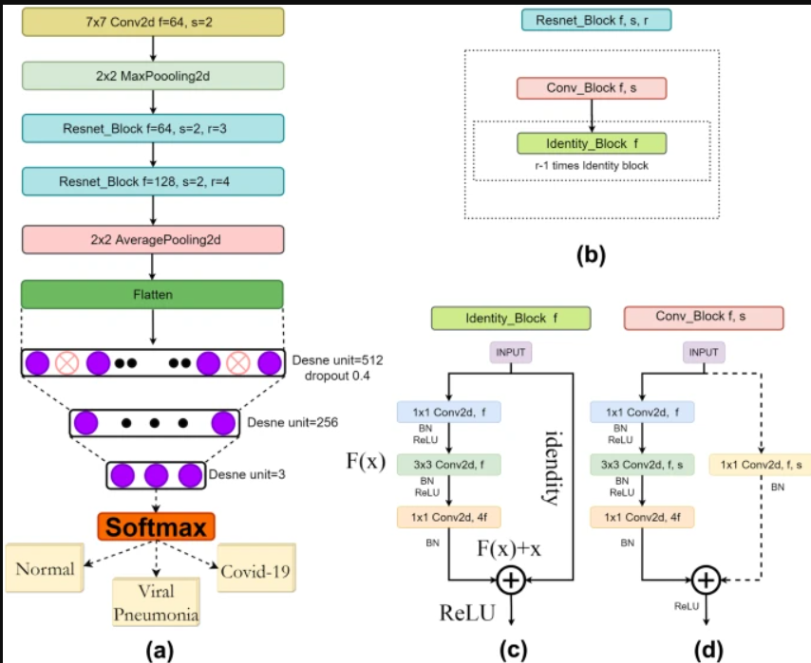

3.2 Modules

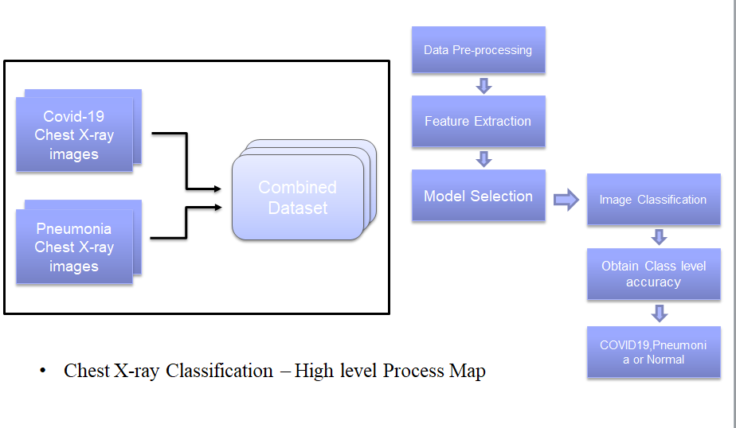

CHAPTER 4: RESULTS AND DISCUSSIONS

4.1 Screenshots of Results (Along with detailed description of Result)
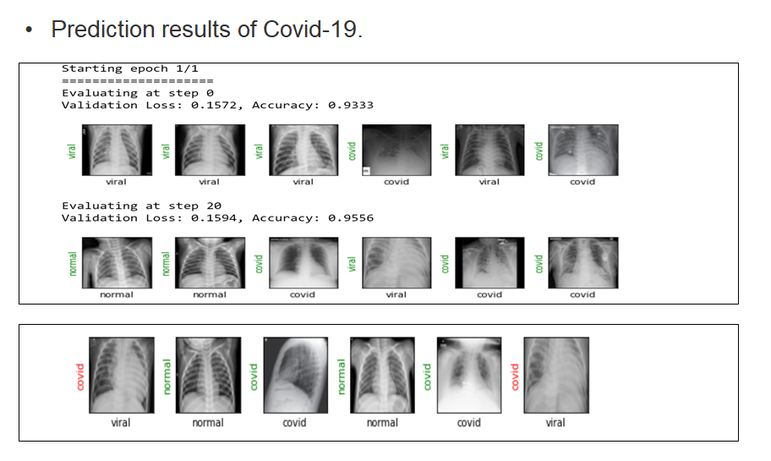
We fine-tuned each model for 100 epochs. The batch size is set to 20, and ADAM optimizer is used to optimize the loss function, with a learning rate of 0.0001. All images are down-sampled to 224x224 before being fed to the neural network (as these pre-trained models are usually trained with a specific image resolution). All our implementations are done in PyTorch [22], and are publicly available at https://github.com/shervinmin/DeepCovid.git 4.2. Evaluation Metrics There are different metrics which can be used for evaluating the performance of classification models, such as classification accuracy, sensitivity, specificity, precision, and F1-score. Since the current test dataset is highly imbalanced (100 COVID-19 images, 3000 Non-COVID image), sensitivity and specificity are two proper metrics which can be used for reporting the model performance: Sensitivity = #Images correctly predicted as COVID-19 #Total COVID-19 Images , Specificity = #Images correctly predicted as Non-COVID #Total Non-COVID Images . (2) 4.3. Model Predicted Scores As mentioned earlier, we focused on four popular convolutional networks, ResNet18, ResNet50, SqueezeNet, DenseNet121. These models predict a probability score for each image, which shows the likelihood of the image being detected as COVID-19. By comparing this probability with a cutoff threshold, we can derive a binary label showing if the image is COVID-19 or not. An ideal model should predict the probability of all COVID-19 samples close to 1, and non-COVID samples close to 0. Figures 6, 7, 8, and 9 show the distribution of predicted probability scores for the images in the test set, by ResNet18, ResNet50, SqueezeNet, and DenseNet-161 respectively. Since Non-COVID class in our study contains both normal cases, as well as other types of diseases, we provide the distribution of predicted scores for three classes: COVID-19, NonCOVID normal, and Non-COVID other diseases. As we can see the Non-Covid images with other disease types have slightly larger scores than the Non-COVID normal cases. This makes sense, since those images are more difficult to distinguish from COVID-19, than normal samples. COVID-19 patient images are predicted to have much higher probabilities than the Non-COVID images, which is really encouraging, as it shows the model is learning to discriminate COVID-19 from non-COVID images. Among different models, it can be observed that SqueezeNet does a much better job in pushing the predicted scores for COVID-19 and Non-COVID images farther apart from each other. 4.4. Model Sensitivity and Specificity Each model predicts a probability score showing the chance of the image being COVID-19. We can then compare these scores with a threshold to infer if the image is COVID-19 or not. The predicted labels are used to estimate the sensitivity and specificity of each model. Depending on the value of the cut-off threshold, we can get different sensitivity and specificity rates for each model. Tables 2, 3, 4, and 5 show the sensitivity and specificity rates for different thresholds, using ResNet18, ResNet50, SqueezeNet, and DenseNet-121 models, respectively. As we can see, all these models achieve very promising results, and the best performing model obtains a sensitivity rate of 98% and specificity rate of 92.9%. SqueezeNet and ResNet18 achieve slightly better performance than the other models. Table 2. Sensitivity and specificity rates of ResNet18 model, for different threshold values. Threshold Sensitivity Specificity 0.1 100% 72.4% 0.17 98% 90.7% 0.2 95% 92.4% 0.25 91% 95.8% 0.35 85% 98.3% 4.5. Small Number of COVID-19 Cases and Model Reliability It is worth mentioning that since so far the number of reliably labeled COVID-19 X-ray images is very limited, and we only have 100 test images in COVID-19 class, the sensitivity and specificity rates reported above may not be reliable. Ideally more experiments on a larger number of test samples with COVID-19 is needed to derive a more reliable estimation of sensitivity rates. We can however estimate the 95% confidence Fig. 8. The predicted probability scores by SqueezeNet on the test set. Fig. 9. The predicted probability scores by DesneNet-121 on the test set. interval of the reported sensitivity and specificity rates here, to see what is the possible range of these values for the current number of test samples in each class. The confidence interval of the accuracy rates can be calculated as: r = z r accuracy (1 − accuracy) N , (3) where z denotes the significance level of the confidence interval (the number of standard deviation of the Gaussian distribution), accuracy is the estimated accuracy (in our cases sensitivity and specificity), and N denotes the number of samples for that class. Here we used 95% confidence interval, for which the corresponding value of z is 1.96. As for COVID-19 diagnostic, having a sensitive model is crucial, we choose the cut-off threshold corresponding to a sensitivity rate of 98% for each model, and compare their specificity rates. Table 6 provides a comparison of the performance of these four models on the test set. As we can see the confidence interval of specificity rates are small (around 1%), since we have around 3000 samples for this class, whereas for the sensitivity rate we get slightly higher confidence interval (around 2.7%) because of the limited number of samples. S Minaee, R Kafieh, M Sonka, S Yazdani, G.J. Soufi / Medical Image Analysis (2021) 7 Table 3. Sensitivity and specificity rates of ResNet50 model, for different threshold values. Threshold Sensitivity Specificity 0.15 100% 78.2% 0.205 98% 89.6% 0.25 93% 94.2% 0.3 90% 97.3% 0.35 85% 98.4% Table 4. Sensitivity and specificity rates of SqueezeNet model, for different threshold values. Threshold Sensitivity Specificity 0.1 100% 89.9% 0.15 98% 92.9% 0.2 96.0% 94.6% 0.4 92% 97.6% 0.5 87% 98.3% 4.6. The ROC Curve, Precision Recall Curve, and Confusion Matrix It is hard to compare different models only based on their sensitivity and specificity rates, since these rates change by varying the cut-off thresholds. To see the overall comparison between these models, we need to look at the comparison for all possible threshold values. One way to do this, is through the precisionrecall curve, which provides the precision rate as a function of recall rate. Precision is defined as the true positive images divided by the total number of images flagged as positive by the model, and the recall is the same as sensitivity rate (defined in Eq (2)). The precision-recall curve of these four models is shown in Figure 10. Fig. 10. The precision-recall curve of four CNN architectures on test set. Another way to do this, is through the Receiver operating characteristic (ROC) curve, which provides the true positive rate as a function of false positive rate. The ROC curve of these four models is shown in Figure 11. All models have a similar performance according to the AUC with the SqueezeNet achieving a slightly higher AUC than the other models. It is Table 5. Sensitivity and specificity rates of DenseNet-121 model, for different threshold values. Threshold Sensitivity Specificity 0.19 98% 75.1% 0.25 95% 88.9% 0.3 90% 94.6% 0.4 79% 98.9% Table 6. Comparison of sensitivity and specificity of four state-of-the-art deep neural networks. Model Sensitivity Specificity ResNet18 98% ± 2.7% 90.7% ± 1.1% ResNet50 98% ± 2.7% 89.6% ± 1.1% SqueezeNet 98% ± 2.7% 92.9% ± 0.9% Densenet-121 98% ± 2.7% 75.1% ± 1.5% worth mentioning that for highly imbalanced test sets, the AUC may not be a good indicative of model performance (as it can be very high), and looking at average-precision and precisionrecall curve would be a better choice in that case. Here we provided both curves for the sake of completeness. Fig. 11. The ROC curve of four CNN architectures on COVID-19 test set. To see the exact number of correctly samples as COVID19 and Non-COVID, the confusion matrices of the two topperforming models – the fine-tuned ResNet18 and SqueezeNet – when classifying the set of 3100 test images are shown in Figures 12 and 13. 4.7. The Heatmap of Potentially Infected Regions We used a simple technique to detect the potentially infected regions, while performing COVID-19 detection. This technique is inspired by the work of Zeiler and Fergus [23], to visualize the result of deep convolutional networks. We start from the top-left corner of the image, and each time occluding a square region of size NxN inside the image, and make a prediction 8 S Minaee, R Kafieh, M Sonka, S Yazdani, G.J. Soufi / Medical Image Analysis (2021) Fig. 12. The confusion matrix of the proposed ResNet18 model. Fig. 13. The confusion matrix of the proposed SqueezeNet framework. using the trained model on the occluded image. If occluding that region causes the model to mis-classify a COVID-19 image as Non-COVID, that area would be considered as a potentially infected region in chest X-ray images (mainly because removing the information of that part led to model mis-classification). On the other hand, if occluding a region does not impact the model’s prediction, we infer that region is not infected. Once we repeat this procedure for different sliding windows of NxN, each time shifting them with a stride of S , we can get a saliency map of the potentially infected regions in detecting COVID19. The detected regions for six example COVID-19 images from our test set are shown in Figure 14. The likely regions of COVID-19 disease marked by our board-certified radiologist are shown in blue on the last row. The generated heatmaps show a good agreement with the radiologist-determined regions of the COVID-19 disease.

CHAPTER 5: CONCLUSIONS AND FUTURE SCOPES

  - Conclusions

Deep Learning Technique | 102 cases positive cases | An Accuracy of 89.2%
CNN (Squeezenet Resnet18 ,Densenet121) | Covid-19 Radiography Dataset | Obtained sensitivity of 97.2  %
Transfer Learning base model | Two types of Datasets are used | An accuracy and obtained sensitivity of 89.2% & 97.2% are obtained respectively

We reported a deep learning framework for COVID-19 detection from Chest X-ray images, by fine-tuning four pre-trained convolutional models (ResNet18, ResNet50, SqueezeNet, and DenseNet-121) on our training set. We prepared a dataset of around 5k images, called COVID-Xray-5k (using images from two datasets), with the help of a board-certified radiologist to confirm the COVID-19 labels. We make this dataset publicly available for the research community to use as a benchmark for training and evaluating future machine learning models for COVID-19 binary classification task. We performed a detail experimental analysis evaluating the performance of each of these 4 models on the test set of of COVID-Xray-5k Dataset, in terms of sensitivity, specificity, ROC, and AUC. For a sensitivity rate of 98%, these models achieved a specificity rate of around 90% on average. This is really encouraging, as it shows the promise of using X-ray images for COVID-19 diagnostics. This study is conducted on a set of publicly available images, which contains around 200 COVID-19 images, and 5,000 non-COVID images. The presented work is reflecting one of the earliest Covid-19 chest X-ray analysis and dataset preparation attempts, which brings time-sensitive relevance in combining these two aspects. However, due to the limited number of COVID-19 images publicly available so far, further experiments are needed on a larger set of cleanly labeled COVID-19 images for a more reliable estimation of the accuracy of these models.

5.2 Future Scope

- In the future, the large dataset for chest x-rays can be considered to validate our proposed model on it.

- It is also advised to consult medical professionals for any practical use case of this project.

- We do not intend to develop a perfect detection mechanism but only research about possible economically feasible ways to combat this disease. Such methods may be pursued for further research to prove their real case implementation

CHAPTER 6: REFERENCE

7.1: Books
- Wong KT, Antonio GE, Hui DS, Lee N, Yuen EH, Wu A, Leung CB, Rainer TH, Cameron P, Chung SS, Sung JJ (2003) Severe acute respiratory syndrome: radiographic appearances and pattern of progression in 138 patients. Radiology 228(2):401–406. https://pubs.rsna.org/doi/10.1148/radiol.2282030593
- Xie X, Li X, Wan S, Gong Y (2006) Mining x-ray images of SARS patients. In: Data Mining. Springer, Berlin, pp 282–294
- Huang C, Wang Y, Li X, Ren L, Zhao J, Hu Y, Zhang L, Fan G, Xu J, Gu X, Cheng Z (2020) Clinical features of patients infected with 2019 novel coronavirus in Wuhan, China. Lancet 395(10223):497–506
- Wang Y, Hu M, Li Q, Zhang XP, Zhai G, Yao N (2020) Abnormal respiratory patterns classifier may contribute to large-scale screening of people infected with COVID-19 in an accurate and unobtrusive manner. arXiv preprint arXiv:2002.05534
- Wang, Wenling, Yanli Xu, Ruqin Gao, Roujian Lu, Kai Han, Guizhen Wu, and Wenjie Tan. ”Detection of SARS-CoV-2 in Different Types of Clinical Specimens.” Jama (2020).
- Yang, Yang, Minghui Yang, Chenguang Shen, Fuxiang Wang, Jing Yuan, Jinxiu Li, Mingxia Zhang et al. ”Laboratory diagnosis and monitoring the viral shedding of 2019-nCoV infections.” medRxiv (2020).
- Ai, Tao, Zhenlu Yang, Hongyan Hou, Chenao Zhan, Chong Chen, Wenzhi Lv, Qian Tao, Ziyong Sun, and Liming Xia. ”Correlation of chest CT and RT-PCR testing in coronavirus disease 2019 (COVID-19) in China: a report of 1014 cases.” Radiology (2020): 200642.
- [5] Kanne, Jeffrey P., Brent P. Little, Jonathan H. Chung, Brett M. Elicker, and Loren H. Ketai. ”Essentials for radiologists on COVID-19: an updateradiology scientific expert panel.” Radiology (2020): 200527.
- [6] Kong, Weifang, and Prachi P. Agarwal. ”Chest imaging appearance of COVID-19 infection.” Radiology: Cardiothoracic Imaging 2, no. 1 (2020): e200028.
- [7] Hansell, David M., Alexander A. Bankier, Heber MacMahon, Theresa C. McLoud, Nestor L. Muller, and Jacques Remy. ”Fleischner Society: glossary of terms for thoracic imaging.” Radiology 246, no. 3 (2008): 697-722.
- [8] Rodrigues, J.C.L. et al. An update on COVID-19 for the radiologist - A British society of Thoracic Imaging statement. (2020) Clinical Radiology.
- Badrinarayanan, Vijay, Alex Kendall, and Roberto Cipolla. ”Segnet: A deep convolutional encoder-decoder architecture for image segmentation.” IEEE transactions on pattern analysis and machine intelligence 39.12: 2481-2495, 2017.
- [19] Ren, S., He, K., Girshick, R., Sun, J. “Faster r-cnn: Towards realtime object detection with region proposal networks”, In Advances in neural information processing systems, 2015.
- [20] Dong, Chao, et al. ”Learning a deep convolutional network for image super-resolution.” European conference on computer vision. Springer, Cham, 2014.
- [21] Minaee, Shervin, Amirali Abdolrashidi, Hang Su, Mohammed Bennamoun, and David Zhang. ”Biometric Recognition Using Deep Learning: A Survey.” arXiv preprint arXiv:1912.00271 (2019).

7.2: Websites
- Prashant Patel, Chest X-ray (Covid-19 & Pneumonia), Accessed at: https://www.kaggle.com/prashant268/chest-xray-covid19-pneumonia
- Ooi GC, Khong PL, Müller NL, Yiu WC, Zhou LJ, Ho JC, Lam B, Nicolaou S, Tsang KW (2004) Severe acute respiratory syndrome: temporal lung changes at thin-section CT in 30 patients. https://pubs.rsna.org/doi/10.1148/radiol.2303030853
- https://www.worldometers.info/coronavirus/
- https://codelabs.developers.google.com/codelabs/keras-flowerssqueezenet/
- https://pytorch.org/

